**f. 61r**

narrac*i*o .;.

of þ*e* preste

& þ*e* pertre

¶

**f. 61v**

**f. 62r**

¶ca*pitulum* •53•

duke of B

**f. 62v**

saint

**f. 63r**

n*ota*

¶ca*pitulum* •54•

¶

no*ta*

iii tymes

of þ*e* da

**f. 63v**

home

¶

frere]

**f. 64r**

**f. 64v**

**f. 65r**

n*ota*

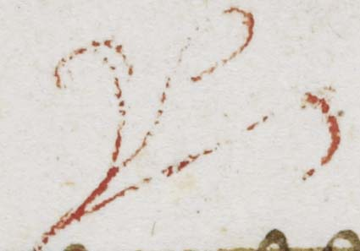

**f. 65v**

me*n* of law

¶ca*pitulum* •55•

**f. 66r**

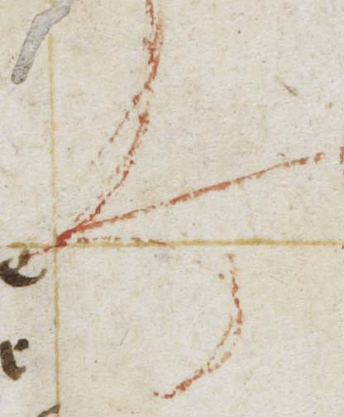 husband

**f. 66v**

seyknes

¶ca*pitulum* •56•

¶



**f. 67r**

• viii • ȝer]

¶ca*pitulum* 57

abu*n*dance

of loue

¶

¶

no*ta*

**f. 67v**

¶

¶ca*pitulum* 57•

**f. 68r**

langor amor*is*

x ȝere]

purg*a*t*ory*

**f. 68v**

ei*us*

charit*at*e*m*

petite et

accipietis

wel of

ters •

¶

no*ta*

**f. 69r**

n*ota*

¶ca*pitulum* •58•

[anker]

¶

no*ta*

¶

**f. 69v**

good preyst

**f. 70r**

¶ca*pitulum* •59•

no*ta* [de rev*e*lac*i*o*ni*b*us*]

o res mirabile

O mutacio

dext*ri* excelci :~

no*ta* ei*us*

dubitac*i*o*n*em

**f. 70v**

Angelus

bonus

fantyses

**f. 71r**

• payne •

laudes deo

xii days

n*ota*

¶ca*pitulum* • 6[0]

¶

**f. 71v**

fyre of loue

vyker

**f. 72r**

n*ota*

¶ca*pitulum* •61•

**f. 72v**

good freyre

\

\

\

Amor i*m*pacie*n*s

men þ*at* sche •

**f. 73r**

\

\

\

No*n* e*st* i*n* ho*min*is potestate p*ro*hibere sp*iritu*m s[anctum]

**f. 73v**

**f. 74r**

¶ca*pitulum* •62•

**f. 74v**

Maria de

oegines

/liber/

¶

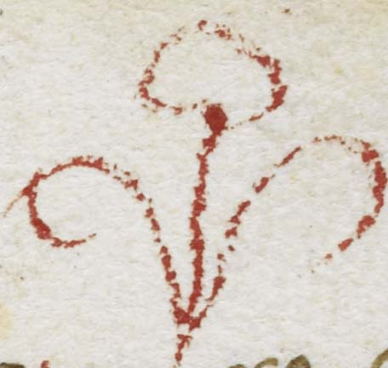

**f. 75r**

pryk of loue

n*ota*

¶ca*pitulum* 63

¶

**f. 75v**

dispect*us*

no*ta contra*

Melton

•:~

¶

¶ca*pitulum* •63•